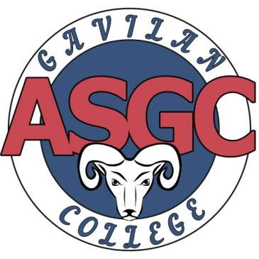

**$200 TEXTBOOK SCHOLARSHIP**

**Download an application from the ASGC website at** [**www.gavilan.edu/student/asgc**](http://www.gavilan.edu/student/asgc)

To qualify, submit a copy of your:

* Class schedule demonstrating that you are enrolled in at least six (6) academic units at Gavilan College
* Transcript indicating a cumulative GPA of 2.5 or above; new students do not need GPA.
* Receipt showing that you have paid for your classes **AND** your ASGC card in full
* Current Educational Plan completed by a Gavilan College Counselor **OR** Degree Works degree audit that indicates that the classes you are enrolled in are necessary to meet your academic goal.

Type a **one to two-page** personal statement answering the following questions:

* What are your future goals?
* How will this scholarship benefit you in reaching your goals?
* Why should we choose you as the recipient of this scholarship?

**Deadline: Wednesday August 15th at 4pm in the Welcome Center of the Gilroy Campus or the Hollister, Morgan Hill, or Coyote Valley Sites.**

For more information, please contact:

* Dr. Blanca Arteaga, ASGC Advisor [barteaga@gavilan.edu](mailto:barteaga@gavilan.edu)
* Ryan Shook, Student Life Coordinator [rshook@gavilan.edu](mailto:rshook@gavilan.edu)